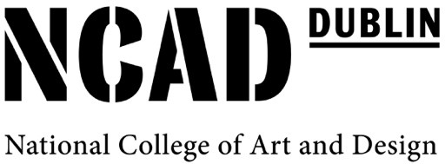

Research Student-led Symposia and Workshops

NCAD has established a fund to support Research Student-led events.

Research students registered at NCAD are invited to propose an event on a ‘live’ research topic that may feature guest-speakers and/or other forms of contributions.

Proposed by one or more research students and hosted by the College, the event should, ideally, be of interest and value to other researchers, but a close connection to the needs or interests of the proposer is welcome too.

Unless a closed event or workshop is proposed, the event will be open to the public.

Events which foster connectivity and exchange with other research students in other institutions are welcome. Partnership with other research or cultural organisations is also encouraged (including co-funding of larger events).

Formats
Events may include

- a symposium on a research theme or topic;
- a workshop on an aspect of expression, technique, publication or dissemination;
- a ‘screening’ with the film makers or authors present;
- a 'crit' of student research work (including writing) with guest/s.

Experimental and unconventional formats are welcome. An event can be a short ‘one off’ (e.g. a one-day workshop) or it can run over a period of time (e.g. weekly event over a month).

Organisation
The initiation and organisation of the event is a learning and networking opportunity. Students who propose an event will be responsible for inviting speakers and programming it. NCAD will ensure that other practical arrangements such as room or Zoom webinar booking, technical support, payment of speaker fees and publicity are in place.

Budget
The total budget for an event is up to 750 Euro. The fund can be used to cover the cost of speaker fees and, when Covid circumstances allow, speaker-related travel costs up. While a short presentation may be met with a modest payment, a lecture usually means a speaker fee of c. 200 Euro. This budget can also be used for reasonable practical costs relating to a workshop. The fee cannot be used to pay for administrative tasks to be undertaken.

Proposal
To make a proposal, please talk your ideas over with your supervisors, and then write to David Crowley crowleyd@staff.ncad.ie addressing the following headings:

- Title of event
- Research purpose (e.g. what kind of research interest or understanding will be supported by this event)
- Likely format (e.g. a symposium with three speakers)
- Technical / space resources needed

- Likely contributors (e.g. speakers)
- Likely audience / participants*
- Proposed dates and times
- Likely costs

Review
Applications will be reviewed by three nominated members of staff. Proposals will be assessed against research interests of the College, the likely benefit to the applicant and to a wider research community, as well as the core principles outlined in the College Strategy.

Deadlines
There is no deadline for applications. But it is unlikely that the College will support more than three such events in a year and so early proposals are encouraged. You will receive a response within a month, so please bear this in mind when scheduling an event.

* An event can be by invitation or have a small number of participants. In this case, it is necessary to say why and how they will be invited / selected.

Sept. 2021

