**Visual Impaired & BlindAT Supports**

**Paid AT Hardware & Software available to all Students Registered with a Diagnosis in Learning Support**

Visual impairment is vision loss as a result of a significant limitation of visual capability resulting from either disease, trauma, or congenital or degenerative conditions that cannot be corrected by conventional means, such as refractive correction, medication, or surgery. People are considered legally blind when visual acuity is 20/200 or less in the better eye with the use of corrective lenses. There are significant variations in visual impairment. Some people can distinguish only light. Some people may have only side vision. Some see everything as a blur while others have blank spots. Blind or visually impaired people often use a white cane or a guide dog.

Our university environment is essentially set up for sighted students. As such, students who are blind or visually impaired can experience significant challenges. Students with visual impairments are one of the most underrepresented groups in Trinity. Students with visual impairments can encounter significant difficulties in the accessibility of their education.

**Strategies staff can use tosupport students**

Students may have disclosed a visual impairment and registered with Learning Support. Implement and support a student’s reasonable accommodations with efficiency and discretion. Be mindful of how being blind or visually impaired may impact a student’s experience of university life.

The effect of visual impairment varies widely. Ask the student about what they think you might need to know. Encourage the student to approach you if they are having difficulty with the way in which you are presenting the information.

Make lecture notes, handouts, and overheads available to the student well in advance of the lecture. This allows time for them to be recorded, enlarged, scanned into the student’s computer, or transcribed into braille.

Make lecture notes available via email or on the internet so that the student can access them using screen reading or magnification software on their computer. Try to keep the physical environment consistent. Blind or visually impaired students may develop mental schemas of how rooms are laid out which makes it easier for them to navigate. If you intend to alter the layout of a room drastically then try to inform the student beforehand and offer them the opportunity to readjust to the new layout. Face the class when speaking and ensure that what is written on the board is also communicated verbally.

You may need to greet a student who is blind or visually impaired by saying your name, as he or she may not recognise your voice.

Never make a fuss of, or feed, a guide dog- he/she is working. Ask for the owner’s permission first.

When guiding a person who is blind/visually impaired, walk slightly ahead of them, allowing them to take your arm just above the elbow. Always ask if a student requires assistance, they may not.

**AT Software Screen Reader JAWS**

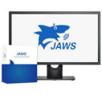

JAWS, Job Access With Speech, is the world's most popular screen reader, developed for computer users whose vision loss prevents them from seeing screen content or navigating with a mouse. JAWS provides speech and Braille output for the most popular computer applications on your PC.

**Portable digital magnifiers**

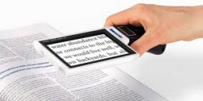

Portable digital magnifiers have a camera on one side that you hold over what you are trying to read, the magnified image is displayed on the other side of the monitor. They come in a number of different screen sizes as a separate device or are also available as an app on your smartphone. Some portable video magnifiers can also connect to your own computer or laptop so that you can angle it in different directions to see something like a board or projector screen in a classroom.

**Traditional handheld magnifiers**

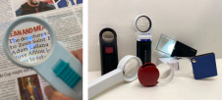

There are a wide variety of magnifying glasses available. They provide different levels of magnification and are available in many sizes and shapes, including folding pocket magnifiers. Some also have a light to illuminate what you are looking at.



**Bookshare Ireland** is the largest accessible digital library in the country, available for all students with print disabilities. Bookshare makes reading easy with all titles available in a format to suit your needs.

**Bookshare Ireland** holds over 1.3 million titles in a variety of accessible formats. The platform hosts over 1000 primary and secondary school books from the school curriculum and thousands of books for 3rd level education. **Contact us** if we are missing a title!

**Bookshare Ireland** is proudly funded by the Department of Education & Skills.

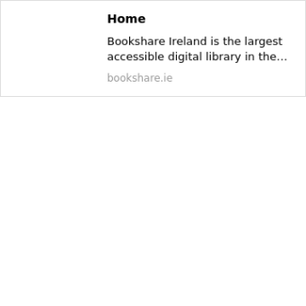

**Resources/links**

**NCBI- Integrating students with sight loss at third level (ncbi.ie)**

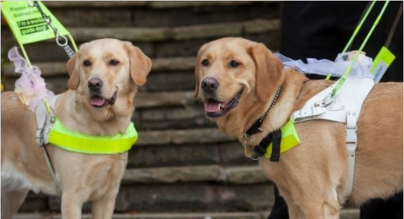**https://vi.ie**

**If you have any issues or queries, please Contact: Assistivetechnology@staff.ncad.ie**