

**Paid AT Hardware & Software available to all Students Registered with a Diagnosis in Learning Support Read&Write contains all the features including:**

Speech feedback,

Word prediction,

Phonetic spell checker,

Talking dictionary and talking calculator.

Convert scanned paper documents into word files that can be read aloud and edited Capture text or images (with their sources) from any application including the Internet. Convert text into audio files for use on portable audio devices such as MP3 players or some mobile phones.

PDF Aloud, which facilitates speech with highlighting in PDF files.

**Read&Write Chrome Browser Extension**



**Go to the Chrome Web Store page, click "Allow extensions from other stores" on the top banner.**

This software is available for students registered with the Disability Service. If you have any issues or queries, please contact:Assistivetechnology@staff.ncad.ie

Visit: https://text.help/gethome in your browser.

1.  Scroll down until you see "Try Read&Write".

2.  Click "Try Read&Write" then select Google Chrome.

You will be brought to the Chrome Web Store page for Read&Write. Click "Add to Chrome".This software is available for students registered with the Disability Service. If you have any issues or queries, please contact: Assistivetechnology@staff.ncad.ie

1.  Visit: https://text.help/gethome in your browser.

2.  Scroll down until you see "Try Read&Write".

3.  Click "Try Read&Write" then select "Windows".

4.  Run the executable file titled "read&write.exe".

5.  Once the app is installed, you will be asked to log in. Use your college provided Google account.

**Windows Read&Write**



1.  Visit: https://text.help/gethome in your browser.

2.  Scroll down until you see "Try Read&Write".

3.  Click "Try Read&Write" then select "Windows".

4.  Run the executable file titled "read&write.exe".

5.  Once the app is installed, you will be asked to log in. Use your college provided Google account.

**Mac Read&Write**



This software is available for students registered with the Disability Service. If you have any issues or queries, please contact: Assistievtechnology@staff.ncad.ie

1.  Visit: https://text.help/gethome in your browser.

2.  Scroll down until you see "Try Read&Write".

3.  Click "Try Read&Write" then select "Mac".

4.  Run the file titled "read&write.dmg".

5.  Once the app is installed, you will be asked to log in. Use your college provided Google account. If you have any issues or queries, please Contact: Assistivetechnology@staff.ncad.ie

**Tablet Read& Write**

1.  On your device, visit: https://text.help/gethome.

2.  Scroll down until you see "Try Read&Write".

3.  Click "Try Read&Write" then select "iPad" or "Android".

4.  Once the app is installed, you will be asked to log in. Use your college provided Google account. If you have any issues or queries, please Contact: Assistivetechnology@staff.ncad.ie

**Ways to use Read&Write**

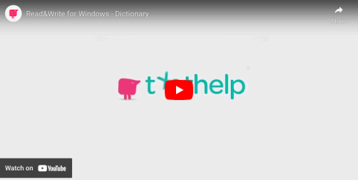

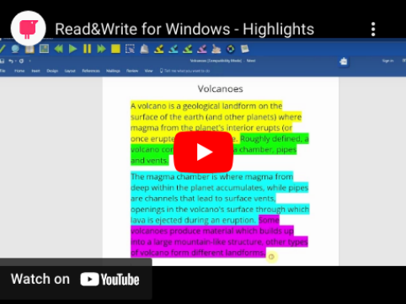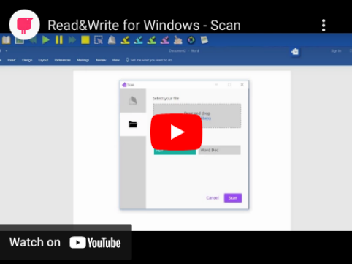

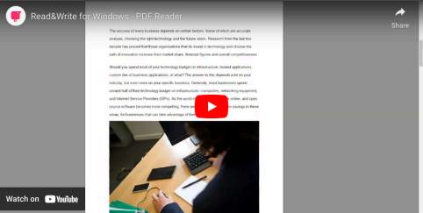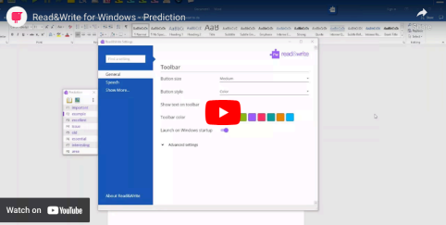

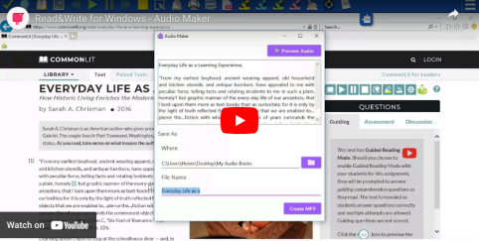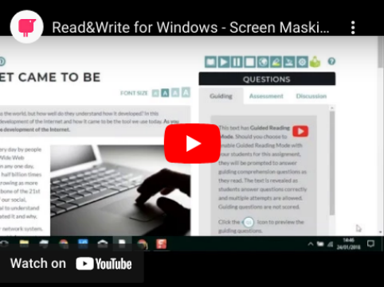

To learn more about Read&Write, you can visit the official site at texthelp.com. Or the support page at support.texthelp.com.

**If you have any issues or queries, please Contact: Assistivetechnology@staff.ncad.ie**