**AT Mind Mapping & Organisationl tools**

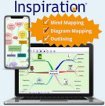

**Paid AT Hardware & Software available to all Students Registered with a Diagnosis in Learning Support**

Inspiration is a mind mapping tool that not only helps you generate ideas but helps you structure these ideas and then you can convert these mind maps into PowerPoint presentations. Mind maps are commonly used in paper and pen form but also online too.

Inspiration is a simple but powerful visual thinking tools for easily creating concept maps, mind maps, diagrams, graphic organizers, outlines, and presentations.

**Full Description**

Brainstorm quickly with the RapidFire® tool.

Use Inspiration’s images, or import your own to represent information and trigger memory. Show relationships between ideas with linking phrases.

Add notes to symbols to expand on ideas.

Add references and hyperlinks using the Citation tool. Inspiration will then create an alphabetically organised Bibliography section at the end of your outline.

Organize ideas effortlessly using the Arrange tool to create various tree diagrams and webs. Apply theming to colour code, highlight key concepts and group information.

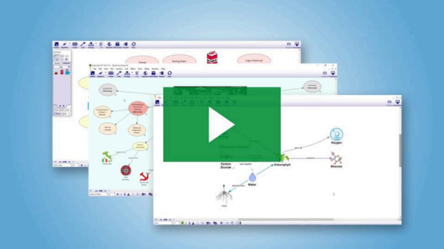

Inspiration 10 ten-minute training video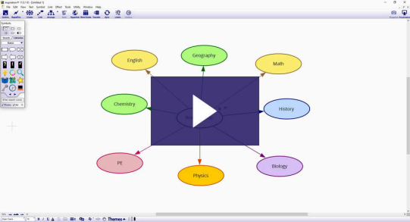

Themes - Inspiration - How to videos 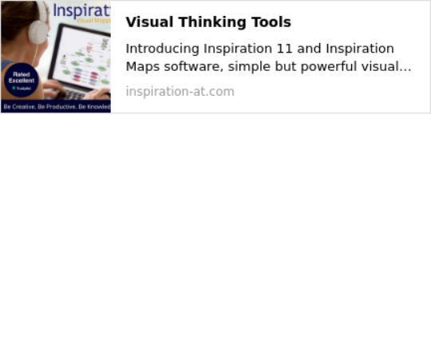

**OTHER MIND MAPPING TOOLS AND WEBSITES:**

Bubbl.us is a mind-mapping product aimed towards literally anyone who needs help organizing their thoughts or any untidy information.

Gliffy creates professional-quality flowcharts, diagrams, floor plans, technical drawings and more.

Mind42 is a browser based online collaborative mind mapping application. Mindmeister is a browser based online collaborative brainstorming and mind mapping application.

Coggle is a browser based online mind map tool that can linked to your Google account.**If you have any issues or queries, please Contact: Assistivetechnology@staff.ncad.ie**