**LiveScribe Pen**

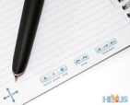

**Features:**

With a sleek new design and enhanced features, the Echo smartpen is LiveScribe's most powerful and easy to use smartpen yet.

**Record Audio and Ink**-Smartpens capture words, diagrams, scribbles, symbols, and audio. They sync everything you hear to what you write.

**Send and Share Notes**-Easily send notes and audio as a pencast by email, or to Google Docs,2 Facebook, Evernote, or your mobile device - all from your paper!3 **Save, Search and Organise Your Notes**-Transfer notes to your Mac or PC so you can search for keywords, or create custom virtual notebooks to organise your notes. **Play Back Audio**-Just tap on a word and your smartpen will replay the audio word for word.

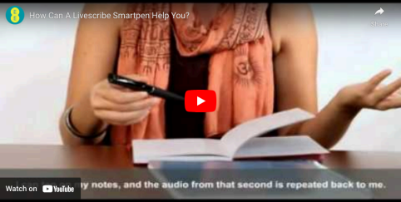

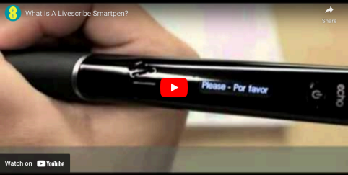

**More Help?**

For more support on using & troubleshooting the LiveScribe pen please check out the LiveScribe website at - http://www.LiveScribe.com/en-gb/support/echo/howto/

If you have any issues or queries, please Contact: **Assistivetechnology@staff.ncad.ie**