Hard of Hearing / Deaf Technologies

**Paid AT Hardware & Software available to all Students Registered with a Diagnosis in Learning Support**

For someone with a hearing impairment, it is easy to believe that their hearing aid is what sets the limits for how well they can hear –Although today’s hearing aids provide good sound reproduction, in demanding environments, users of hearing aids still experience the technology’s limitations.

**Hearing technologies aim to break down such barriers :**

A microphone captures what is being said around a meeting table or of an individual sound source, such as a telephone or a lecturer.

The sound is processed so that speech is enhanced and background noise filtered out. The sound is then transmitted to a receiver, and from there to the user’s hearing aid, hearing implant or headphone.

**If you have any issues or queries, please Contact: Assistivetechnology@staff.ncad.ie**

Roger Pen

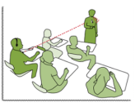

An all-inclusive wireless microphone for use at work or home, the Roger Pen offers best speech understanding in noise and over distance, plus Bluetooth connectivity

**Full speech understanding**

Understand up to 62% more in noise and over distance compared to people with no hearing loss

**Hassle-free**

Microphone settings automatically adjust to noise levels and speakers around you Audio **loops Systems**

A loop System enables hearing aid users hear various sound sources in large rooms or reception areas, in auditoriums, offices, theatres, or other large public areas.

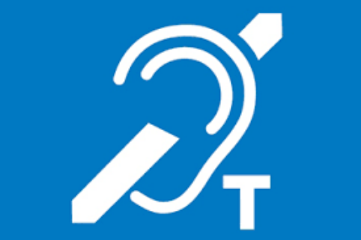

A loop of insulated wire is present around a designated listening area connected to a power source, an amplifier, and a microphone.

Hearing aids which have the ‘T’ switch can be set at this position, thus allowing the user to receive a signal, which carries from the microphone to the amplifier and is transmits through to the loop wire, like a transmitting aerial.

Live Transcribe for Android

**This app is only available for Android. We are currently looking for an iOS equivalent.**

Live Transcribe is an Android application developed by Google. This app uses the accessibility icon in your phone's navigation bar so you can easily access it.

You can download Live transcribe as a regular app if it is not already present on your phone. You can then enable it in your phone's accessibility settings.

You can find more information at the Android Accessibility Help page for Live Transcribe. 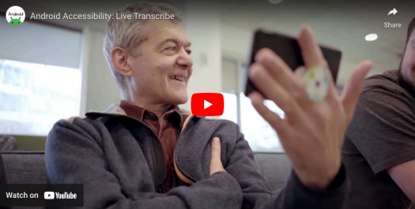

Otter.ai



Typing out transcripts or taking notes during a meeting takes too much time and effort. And it is precisely the kind of “work about work” Otter.ai wants to help reduce. Otter turns your voice conversations into smart notes that you can easily search and share. You can use it to take notes at your meetings and interviews, capture your thoughts and ideas while you are driving in the car, and transcribe your existing recordings and podcasts.

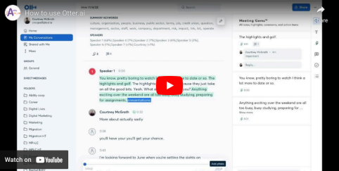

**VoxSci**

VoxSci transcribes your voicemails into text and delivers them to your mobile as a text (SMS) message and/or as an email with MP3 attachment. Alternatively, you can read/listen to your voicemails via our FREE App.

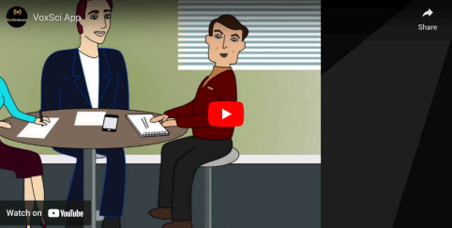

CHIME free Resources creating accesibility for Students that are Deaf or Hard of Hearing

How to Display Captions Ways to display Captions



**1. PowerPoint; show live speech as captions**

Even if you don’t intend displaying a presentation, use PowerPoint just to have captions of your talk. Open a new blank document and follow the instructions below

>’Slide Show’ tab

> select ‘Always Show Subtitles’

> ‘Subtitle Settings’ drop-down list

i. select ‘microphone’ to choose your device’s microphone.

ii select position of where you want captions to appear.

iii select ‘More Settings’ to change size/appearance of captions. Then you can toggle captions on or off in Powerpoint by doing this;

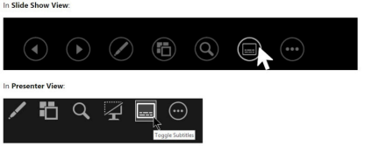

Telephone Text

Email

Website

01 462 0377

086 171 6284

dublinsouth@chime.ie www.chime.ie

CHY Number

Registered Charity Number Skype ID

Address

5633

20008772

Chime Tallaght

Unit G/H Exchange Hall, Belgard Sq North, Dublin 24

Directors

Thomas Maguire (Chairperson), Kevin Coleman, Sandra Creagh, Martina Cummins, Patrick Flynn, Ciaran McCormack, Deirdre Nicholl, Jennifer Robertson

Registered in Dublin No 21627 as National Association for the Deaf

How to Display Captions 

**2. Google Chrome to caption speech in videos etc** Turn on Captions for media you play in Chrome.

1. Ensure your device’s microphone is on

2. On your computer, open Chrome .

3. At the top right, click More

Settings .

4. At the bottom of the Settings page, click 5. Turn on Live Caption.

**3. Microsoft Office Word**

Accessibility.

This provides another simple way to transcribe spoken words and can be shared on a screen or used locally on a laptop

• Ensure your device’s microphone is on

• Open a blank word document

• Go to ‘Dictate’ in top task bar

• In the drop-down list select ‘dictate’

• Change font size to 78 for easy reading in large rooms

• Change to landscape view by going to ‘Layout’ tab, then select ‘Orientation’, then select ‘Landscape’

Telephone Text

Email

Website

01 462 0377

086 171 6284

dublinsouth@chime.ie www.chime.ie

CHY Number

Registered Charity Number Skype ID

Address

5633

20008772

Chime Tallaght

Unit G/H Exchange Hall, Belgard Sq North, Dublin 24

Directors

Thomas Maguire (Chairperson), Kevin Coleman, Sandra Creagh, Martina Cummins, Patrick Flynn, Ciaran McCormack, Deirdre Nicholl, Jennifer Robertson

Registered in Dublin No 21627 as National Association for the Deaf

How to Display Captions 

**4. Phone Settings for Captions**

iphone 11 & later only (free)

➢

Go to Settings Go to ‘Accessibility’ Go to ‘Subtitles and Captioning’ Go to ‘Closed Captions + SDH’ – Turn on

➢

Then go back to ‘Live Captions (Beta)’ Go to ‘Live Captions’ – turn on

➢

➢

➢ ➢

Then, to read what people in the vicinity are saying;

Press this tiny icon anywhere).

on your screen (you can move it

It will expand it to look like this



Set it to ‘listen’ (or ‘pause listen’)

Press the double arrow to expand it further. It will transcribe what is being said in the vicinity.

Collapse it back into the small icon when finished by pressing the arrow on the left.

OR

To read what people on your phone call are saying; When you accept a phone call, turn on the loudspeaker 1st, then press the small icon, (then press the double arrow if you want it to fill the whole screen). It will transcribe what your caller is saying during the phone call.

Telephone Text

Email

Website

01 462 0377

086 171 6284

dublinsouth@chime.ie www.chime.ie

CHY Number

Registered Charity Number Skype ID

Address

5633

20008772

Chime Tallaght

Unit G/H Exchange Hall, Belgard Sq North, Dublin 24

Directors

Thomas Maguire (Chairperson), Kevin Coleman, Sandra Creagh, Martina Cummins, Patrick Flynn, Ciaran McCormack, Deirdre Nicholl, Jennifer Robertson

Registered in Dublin No 21627 as National Association for the Deaf

How to Display Captions 

Collapse it back into the small icon when finished by pressing the arrow on the left

Samsung Android phones (free)

➢

1 .

Open

➢

Device Settings

2 .

➢

Tap on

Accessibility

3

➢

Tap on

Hearing enhancements.

4 .

Turn on

live caption

Double tap the icon to expand

Move it anywhere on the screen

**5. Apps**

**Otter Transcribe Voice Notes** (paid subscription or partial service is free) 

- Available in app stores or https://help.otter.ai/hc/en

us/articles/360047538094-Conversation-import-and-app-limits-on-the-Basic free-plan

- Works across multiple devices; phones, tablets, laptops, Teams, etc

**Live Transcribe** (free in Google Play)



Telephone Text

Email

Website

01 462 0377

086 171 6284

dublinsouth@chime.ie www.chime.ie

CHY Number

Registered Charity Number Skype ID

Address

5633

20008772

Chime Tallaght

Unit G/H Exchange Hall, Belgard Sq North, Dublin 24

Directors

Thomas Maguire (Chairperson), Kevin Coleman, Sandra Creagh, Martina Cummins, Patrick Flynn, Ciaran McCormack, Deirdre Nicholl, Jennifer Robertson

Registered in Dublin No 21627 as National Association for the Deaf

How to Display Captions Works on Android phones, tablets, laptops etc -

**6. Zoom**

The host who sets up the meeting MUST enable automated captions themselves, in their own account’s Advance Settings, then attendees will have the option to turn them on or off during the meeting.

Attendees CANNOT turn captions on unless the host enables captions in their Advanced Settings beforehand

How the Host enables Automated Captions;

Sign-in to your online Zoom account via web only.

Open Zoom Settings

> Personal Settings

>In Meeting (Advanced)

>Automated Captions – toggle this to enable it

>Tick the tiny box (ignore their waffle, it is meaningless). A second tiny box will then appear, so tick this too (again, there is more confusing waffle to ignore. Don't be lured into buying an app or thinking that you have to assign a typist, that is not what they actually mean). Click ‘enable’

Click ‘Save’

NOTE At the start of each meeting, hosts will also have to enable captioning during that meeting,

to ensure they are included in recordings. If captions do not appear automatically, do the following; >In the bottom control bar of your zoom meeting, just right of centre, is the CC button with 'Live Transcript' written underneath. Click this cc button and a pop-up window appears. > Select 'Enable Auto-Transcription'

If the host.

button does not appear at the start of a meeting, then it has not been enabled by the

Inform attendees at the start of your meeting that they can turn captions on and off. They can do

this by going to the

button at the bottom of their screen and selecting their choice. Attendees

watching on a mobile phone will usually find the bottom right-hand corner of their screen.

in the little keyboard symbol in the top or

Telephone Text

Email

Website

01 462 0377

086 171 6284

dublinsouth@chime.ie www.chime.ie

CHY Number

Registered Charity Number Skype ID

Address

5633

20008772

Chime Tallaght

Unit G/H Exchange Hall, Belgard Sq North, Dublin 24

Directors

Thomas Maguire (Chairperson), Kevin Coleman, Sandra Creagh, Martina Cummins, Patrick Flynn, Ciaran McCormack, Deirdre Nicholl, Jennifer Robertson

Registered in Dublin No 21627 as National Association for the Deaf

**7. TV Captions**

How to Display Captions 

All smart TVs have captions. How you turn them on depends on the make and model of your TV and the type of remote control you use.

Try ‘Settings’ , then ‘Accessibility’, then ’Sound’, then select the closed captioning option 

**8. YouTube**

Click in the bottom bar of the screen to turn captions on. (even if the video wasn’t made with captions, the viewer can still turn on automated captions)

**To turn on live captions on a laptop, do any ONE of the following**

**9.** : ▪ Turn on the **Live captions** toggle in the quick settings **Accessibility** flyout. (To open quick settings, select the battery, network, or volume icon on the taskbar.)

▪

Press Windows logo key + Ctrl + L. Select **Start** > **All apps** > **Accessibility** > **Live captions**. Go to **Settings** > **Accessibility** > **Captions**, and turn on the **Live captions** toggle. ▪

▪ When turned on the first time, live captions will prompt you to download live captions language files to be used by on-device speech recognition. If your language is not available, you can use another language during setup.

**To caption your own speech:**

1. Select the Settings button in the live captions window.

2. Select **Preferences**, and turn on the **Include microphone audio** option. **Note:** When you next turn on live captions, this option will be turned off.

To check your device’s microphone configuration, see **Settings** > **System** > **Sound** and review the **Input** options.

Telephone Text

Email

Website

01 462 0377

086 171 6284

dublinsouth@chime.ie www.chime.ie

CHY Number

Registered Charity Number Skype ID

Address

5633

20008772

Chime Tallaght

Unit G/H Exchange Hall, Belgard Sq North, Dublin 24

Directors

Thomas Maguire (Chairperson), Kevin Coleman, Sandra Creagh, Martina Cummins, Patrick Flynn, Ciaran McCormack, Deirdre Nicholl, Jennifer Robertson

Registered in Dublin No 21627 as National Association for the Deaf

**If you have any issues or queries, please Contact: Assistivetechnology@staff.ncad.ie**