**Glean**



**Paid AT Hardware & Software available to all Students Registered with a Diagnosis in Learning Support**

Glean is a unique software package to help with navigating, annotating and organizing digital recordings of lectures and seminars. Glean shows you a visual representation of the digital recording. With this tool you can quickly review, reference and identify key sections of speech to support editorial work or research.

**Features:**

Importing Audio, Images, Text and Slides

Grouping, editing and highlighting audio segments

Linking notes, images and slides with matching audio recordings

Quick review and organization of previous Notetaker files

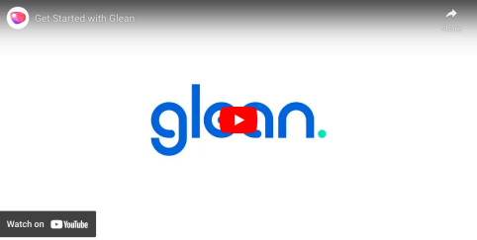**Using Glean**

Glean works as a Chrome Web App. It will work on any operating system as long as a Chrome based browser like Google Chrome or Microsoft Edge is installed.

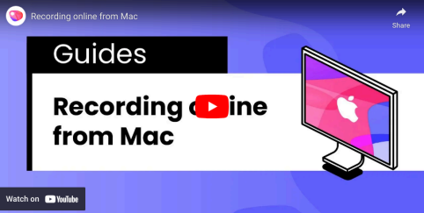**More Help?**

For more support on using & troubleshooting Glean please check out the - Glean website **If you have any issues or queries, please Contact: Assistivetechnology@staff.ncad.ie**