**C-Reader Pen**

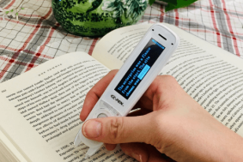

**Paid AT Hardware & Software available to all Students Registered with a Diagnosis in Learning Support**

The C-PEN Reader Pen is a robust, portable, pocket-sized reading pen that reads text out loud with a human-like digital voice. There are different types of C pens/Scan pens as some are for exam purposes while others have a wider purpose.

**Most useful for:** ReaderPen is designed to promote independent learning and may be useful for a person who has reading difficulties.

**C-Reader Pen Key Features**

Words or lines of text read out loud

Simple built-in dictionaries

Scan, store and transfer to a PC or Mac (1GB+ of storage/no software required) Scan direct to the cursor on a computer

The Pen also has a voice memo recorder

Develops reading comprehension

Nurtures language learners

Supports multiple languages

Promotes reading independence

Improves student confidence

Maintains effectiveness when distance learning

No additional software required

Includes earphones (3.5mm connector)

**If you have any issues or queries, please Contact: Assistivetechnology@staff.ncad.ie**