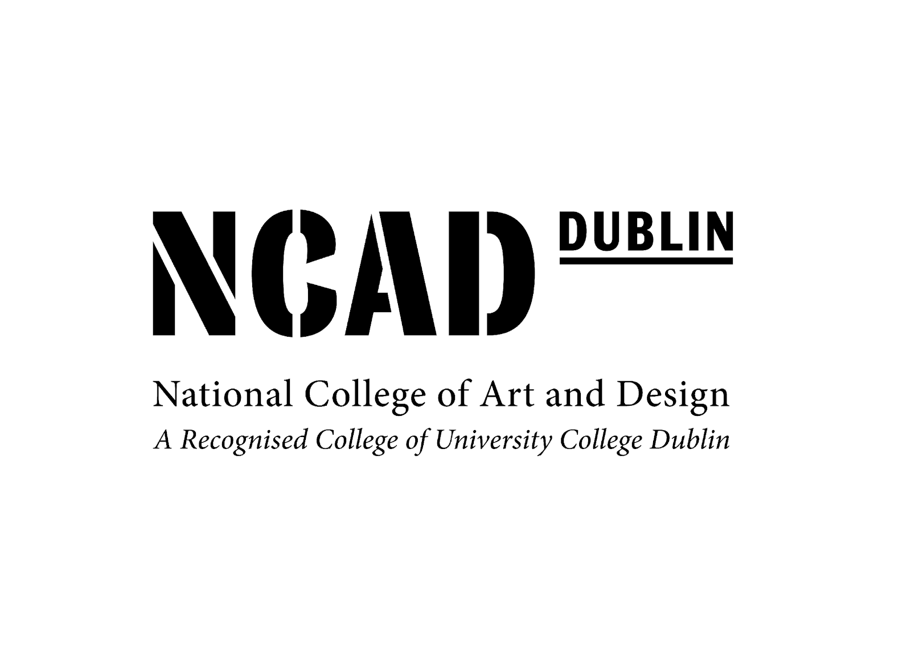

Annual Report under the Protected Disclosures Act 2014

Report for the year ended 31st December 2018

There were no protected disclosures made to the College during the year.

