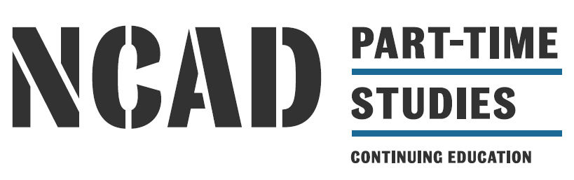

Higher Diploma in Art – Digital Portfolio Presentation 2020

Higher Diploma in Art | Higher Diploma | Department of Continuing Education
NFQ: | LEVEL 8 | CODE: AD082
CREDIT: | 90 ECTS | 6.15 - 9 pm
Duration: 2 years | 14 modules | Autumn & Spring
Programme co-ordinators: Felicity Clear, BA, MA, Beth O'Halloran, BA, MA, Elaine Leader, BA, MA, Fiona Loughnane, BA, MA, Emma Mahony, PhD

NCAD School of Education offers a part-time undergraduate higher diploma in art and design. This programme is an intensive two-year course which provides students with an opportunity to explore a range of materials, to develop skills in different subjects, and establish a direction for their visual art practice.
Students who have successfully completed a Certificate in one of the following: DVI /VAP / PDI and want to apply for the part-time Higher Diploma course should present a portfolio. Using the portfolio guidelines, the portfolio will now be submitted digitally and not in a physical format. Submissions to be emailed to the CEAD office at cead@staff.ncad.ie. Closing date for applications is June 19th at 5pm. Please make sure you have your name and contact details included in the portfolio.

Entry Requirements:
Students should complete a Certificate course with CEAD and carry forward 20 (30) ECTS in order to be eligible to access the Higher Diploma course. Graduates of the Drawing and Visual Investigation, Visual Art Practice, PDI programmes are eligible to apply for this course. Students’ who have not completed a Certificate with CEAD but have completed accredited programmes with equivalent learning outcomes, are eligible to apply but will have to demonstrate that they have met the learning outcomes through RPL. The Higher Diploma course will commence in the autumn and will involve a minimum of two nights per week, some Saturdays as well as full-time workshops. Each academic year is approximately 30 weeks duration.

Prior to submitting a portfolio application, you might seek the advice of your module/programme tutor on selection of images, and other visual material for the portfolio. Please note it is important to address the exercises set out below but also to show a range of appropriate skills and material exploration.

Digital portfolio presentation, saved as a PDF, containing the following:
- Name and contact details
- Introduction Statement: A few lines letting us know what your interests or topics were in the work you are presenting from your previous course/s (Max 100 words).
- 10 slides of images of work: It would be helpful if you could provide some idea of the dimensions of the work. Either by giving the measurements on the slide as a caption or by putting a pencil (for example) beside the work when you photograph it.
- Sound or film files can be sent separately or as links within the PDF.
- 3 slides (1 slide each) for the three worksheets from the portfolio brief outlined below.
- 8 slides – of notebook pages: which should include; 2 pages which demonstrate drawing skills; 6 pages which include research, which could include research into your themes or topics, research into relevant contemporary artists, research into materials and processes.

The portfolio should contain work that contains the following:
- Work indicating your range of visual interests, including collecting of source material for projects
- Ideas or themes informing your work
- Shows inventive thinking in approach to work
- Shows how you sustain ideas, the depth and focus of your work
- Demonstrates how you record and describe ideas visually
- Indicates your level of knowledge of art and design disciplines
- Show skills in drawing including drawings made from observation or drawing demonstrating a critical approach
- Articulates why you are interested in undertaking the course

Please name your pdf file in the following way:
Your name: Mary Joe Another…H. Diploma application 2020
*If you have difficulties making a PDF or slide presentation, your digital portfolio can be made in Power-Point using a basic clean template*

BRIEF for Portfolio –PART-TIME

You are required to undertake and complete a brief for your application which is similar to portfolio submission for entry to year one of the full-time undergraduate degree course. It will involve making / completing:

- 1 mind map = 1 worksheet,*
- 1 observational study = 1 worksheet,
- 1 invention and problem-solving task = 1 worksheet

Therefore, students are required to submit 3 worksheets, see details of exercises below.
*An ideas/worksheet is a large sheet of A1 or A2 size used for accumulating visual information, ideas and experiments related to a theme or topic. Any medium or device can be used – drawing, collage, photographs, diagrams- whatever is appropriate. The worksheets should be two-dimensional and therefore should contain photographs of any three-dimensional information or experiments or developments.

The Brief

Exercise One – Mind Map

Take one of the following themes as a starting point for your work:

Navigation / Gadget / Struggle/ Home / Skin

Make a visual list of as many different examples as possible for each of the themes (Brainstorming). Choose one theme and present your ideas in the form of a mind-map. A mind-map is a way to show in visual form, the relationships between different ideas. Produce one mind-map based on workings around the theme. Identify as many unusual and interesting examples as possible (e.g. Could your eyelid be a gadget? Is your bag a home? Are bedclothes like a skin?) Your mind map should be thorough and comprehensive, as other parts of the brief are based on their contents. Things identified in your mind-maps are called items in the rest of this brief.

1 worksheet

Exercise Two – Observational Drawing

Exercise Two
Return to the mind map in exercise one. Select an item/object from your mind map that exists in the real world and get an example of it. Take apart or carefully dismantle your selected item. First carefully record through observational drawing this dismantling process. Then visually record (through any medium of your choice) all of the pieces arranged in a new way such as stacked, pushed in a corner, hung, floating-or according to a criteria such as material, colour size or weight.

1 worksheet

Exercise Three – Invention and Problem Solving

This task presents you with problem solving challenges. Your work can be carried out in two or three dimensions, or it can be a combination of 2d and 3d processes and / or moving images.

Choose one task from the following list of tasks

Invent / demonstrate or illustrate one of the following:
- Record two different overlaps
- Draw up or make four new letters for the alphabet
- Show two different ways to keep flees off a dog
- Invent a new way of recording time
- Record four situations where you see things leaning at odd angles
- Invent your own problems, describe it and solve it
- Show three ways to bridge a gap
- Make a bundle and record it through colour
- Visually document your favourite sound or smell
- Invent a way to re-direct water

Work can be done in any form or combination of drawing, collage, models and or various media
1 worksheet

Total = 3 worksheets altogether

Criteria for portfolio selection:
- Inventiveness and creativity in approach to briefs/projects/subjects,
- Analysis and critical observations,
- Demonstrate a range of skills: research, technical, observation, drawing, problem solving,
- Show cultural and visual awareness,
- Show a willingness to experiment with concepts and materials
- Demonstrate a commitment to art and design disciplines over a period of time,
- Clearly articulate why you want to participate on the course and how it relates to your personal/professional development

Application process and course information:

Application form available from email cead@staff.ncad.ie or phone 636 4214 / 636 4278

The Higher Diploma course will involve minimum attendance of two evenings per week, some Saturdays and at least one full-week block in May. Students are required to submit work for the CEAD Exhibition and participate in the display of their work.

